Computer Graphics, Ex#3

# General flow description

Starting for “renderLine” (inside RayTracer), we’re casting a ray for each line in the canvas.

Each ray casted, may or may not hit an object in its way.

Once we received the Ray from the “castRay” call, then we calculate its color.

The way we calculate the color is by checking intersections of the ray and objects in space.

We test which light we received and what object the ray intersected with and what its surface “look” like.

Once we have all that, we inject the color to the canvas and continue to the next line

# Classes flow chart

(Also attached as regular PNG in the main directory)

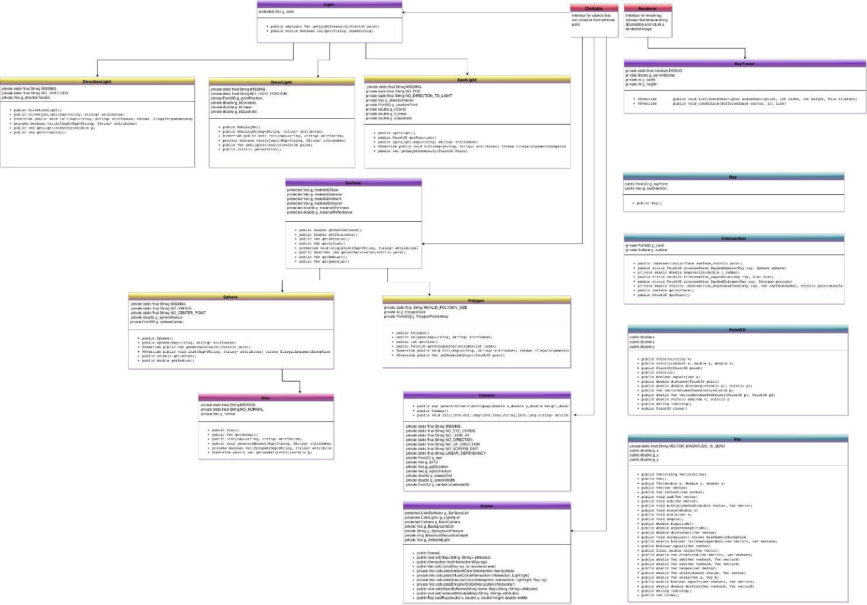

# Created by

* Matan Gidnian - 200846905
* Aviad Hahami - 302188347